**BANK LOAN REPORT QUERY DOCUMENT**

1. **BANK LOAN REPORT | SUMMARY**

**KPI’s:**

**Total Loan Applications**

SELECT COUNT(id) AS Total_Loan_Applications FROM bank_loan_data;



**MTD Total Loan Applications**

SELECT COUNT(id) AS MTD_Total_Loan_Applications FROM bank_loan_data

WHERE MONTH(issue_date) = 12 AND YEAR(issue_date) = 2021 ;



**PMTD Total Loan Applications**

SELECT COUNT(id) AS PMTD_Total_Loan_Applications FROM bank_loan_data

WHERE MONTH(issue_date) = 11 AND YEAR(issue_date) = 2021 ;  


**Total Funded Amount**

SELECT SUM(loan_amount) AS MTD_Total_Funded_Amount FROM bank_loan_data;



**MTD Total Funded Amount**

SELECT SUM(loan_amount) AS MTD_Total_Funded_Amount FROM bank_loan_data

WHERE MONTH(issue_date) = 12 AND YEAR(issue_date) = 2021 ;  


**PMTD Total Funded Amount**

SELECT SUM(loan_amount) AS PMTD_Total_Funded_Amount FROM bank_loan_data

WHERE MONTH(issue_date) = 11 AND YEAR(issue_date) = 2021 ;  


**Total Amount Received**

SELECT SUM(total_payment) AS Total_Amount_Received FROM bank_loan_data;  


**Total MTD Amount Received**

SELECT SUM(total_payment) AS MTD_Total_Amount_Received FROM bank_loan_data

WHERE MONTH(issue_date) = 12 AND YEAR(issue_date) = 2021 ;  


**Total** **PMTD Amount Received**

SELECT SUM(total_payment) AS PMTD_Total_Amount_Received FROM bank_loan_data

WHERE MONTH(issue_date) = 11 AND YEAR(issue_date) = 2021 ;  


**Average Interest Rate (upto 4 values)**

SELECT ROUND(AVG(int_rate), 4)*100 AS Avg_Interest_Rate FROM bank_loan_data;



**MTD Average Interest Rate**

SELECT ROUND(AVG(int_rate), 4)*100 AS MTD_Avg_Interest_Rate FROM bank_loan_data

WHERE MONTH(issue_date) = 12 AND YEAR(issue_date) = 2021 ;  


**PMTD Average Interest Rate**

SELECT ROUND(AVG(int_rate), 4)*100 AS PMTD_Avg_Interest_Rate FROM bank_loan_data

WHERE MONTH(issue_date) = 11 AND YEAR(issue_date) = 2021 ;  


**Average DTI**

SELECT ROUND(AVG(dti), 4)*100 AS Avg_DTI FROM bank_loan_data;  


**MTD Avg DTI**

SELECT ROUND(AVG(DTI), 4)*100 AS MTD_Avg_DTI FROM bank_loan_data

WHERE MONTH(issue_date) = 12 AND YEAR(issue_date) = 2021 ;   


**PMTD Avg DTI**

SELECT ROUND(AVG(DTI), 4)*100 AS PMTD_Avg_DTI FROM bank_loan_data

WHERE MONTH(issue_date) = 11 AND YEAR(issue_date) = 2021 ;  


**GOOD LOAN ISSUED**

**Good Loan Percentage**

SELECT

(COUNT (CASE WHEN loan_status = 'Fully Paid' OR loan_status = 'Current' THEN id END)*100)

/

COUNT(id) AS Good_Loan_Percentage

FROM bank_loan_data;   


**Good Loan Applications**

SELECT COUNT(id) AS Good_Loan_Applications FROM bank_loan_data

WHERE loan_status = 'Fully Paid' OR loan_status = 'Current';  


**Good Loan Funded Amount**

SELECT SUM(loan_amount) AS Good_Loan_Funded_Amount FROM bank_loan_data

WHERE loan_status = 'Fully Paid' OR loan_status = 'Current';  


**Good Loan Total Received Amount**

SELECT SUM(total_payment) AS Good_Loan_Received_Amount FROM bank_loan_data

WHERE loan_status = 'Fully Paid' OR loan_status = 'Current';  


**BAD LOAN ISSUED**

**Bad Loan Percentage**

SELECT

(COUNT (CASE WHEN loan_status = 'Charged Off' THEN id END)*100)

/

COUNT(id) AS Bad_Loan_Percentage

FROM bank_loan_data;



**Bad Loan Applications**

SELECT COUNT(id) AS Bad_Loan_Applications FROM bank_loan_data

WHERE loan_status = 'Charged Off';  


**Bad Loan Funded Amount**

SELECT SUM(loan_amount) AS Bad_Loan_Funded_Amount FROM bank_loan_data

WHERE loan_status = 'Charged Off';  


**Bad Loan Total Received Amount**

SELECT SUM(total_payment) AS Bad_Loan_Received_Amount FROM bank_loan_data

WHERE loan_status = 'Charged Off';  


**LOAN STATUS**

**LOAN STATUS**

SELECT

loan_status,

COUNT(id) AS Total_Loan_Applications,

SUM(total_payment) AS Total_Amount_Received,

SUM(loan_amount) AS Total_Funded_Amount,

Avg(int_rate *100) AS Interest_Rate,

Avg(DTI *100) AS DTI

FROM

bank_loan_data

GROUP BY

loan_status;  
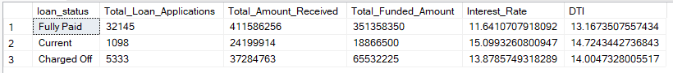

SELECT

loan_status,

SUM(total_payment) AS MTD_Total_Amout_Received,

SUM(loan_amount) AS MTD_Total_Funded_Amount

FROM

bank_loan_data

WHERE

MONTH(issue_date) = 12

GROUP BY

loan_status;

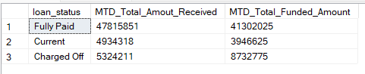

1. **BANK LOAN REPORT | OVERVIEW**

**MONTH**

SELECT

MONTH(issue_date) AS Month_Number,

DATENAME(MONTH, issue_date) AS Month_Name,

COUNT(id) AS Total_Loan_Applications,

SUM(loan_amount) AS Total_Funded_Amount,

SUM(total_payment) AS Total_Amount_Received

FROM

bank_loan_data

GROUP BY

MONTH(issue_date), DATENAME(MONTH, issue_date)

ORDER BY

MONTH(issue_date), DATENAME(MONTH, issue_date);

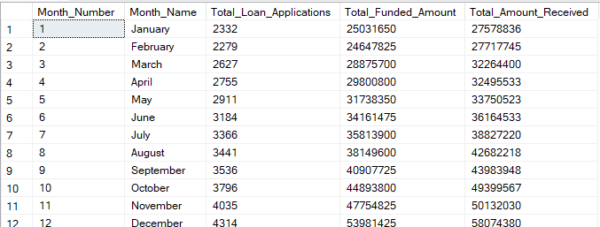

**STATE**

SELECT

address_state AS Address,

COUNT(id) AS Total_Loan_Applications,

SUM(loan_amount) AS Total_Funded_Amount,

SUM(total_payment) AS Total_Amount_Received

FROM

bank_loan_data

GROUP BY

address_state

ORDER BY

COUNT(id) DESC;

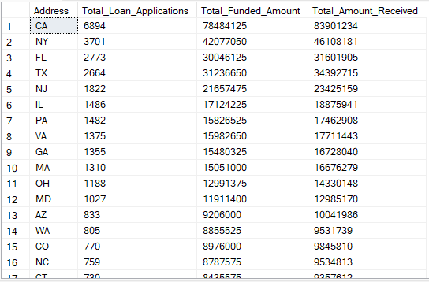

**TERM**

SELECT

term AS Term,

COUNT(id) AS Total_Loan_Applications,

SUM(loan_amount) AS Total_Funded_Amount,

SUM(total_payment) AS Total_Amount_Received

FROM

bank_loan_data

GROUP BY

term

ORDER BY

term;



**EMPLOYEE LENGTH**

SELECT

emp_length AS Employee_Length,

COUNT(id) AS Total_Loan_Applications,

SUM(loan_amount) AS Total_Funded_Amount,

SUM(total_payment) AS Total_Amount_Received

FROM

bank_loan_data

GROUP BY

emp_length

ORDER BY

COUNT(id) DESC;

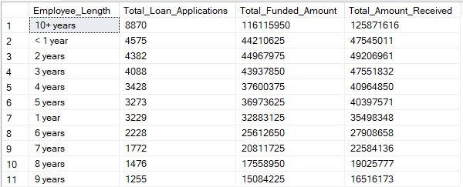

**PURPOSE**

SELECT

purpose AS Purpose,

COUNT(id) AS Total_Loan_Applications,

SUM(loan_amount) AS Total_Funded_Amount,

SUM(total_payment) AS Total_Amount_Received

FROM

bank_loan_data

GROUP BY

purpose

ORDER BY

COUNT(id) DESC;

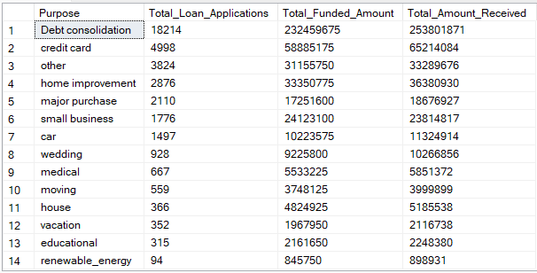

**HOME OWNERSHIP**

SELECT

home_ownership AS Home_OwnerShip,

COUNT(id) AS Total_Loan_Applications,

SUM(loan_amount) AS Total_Funded_Amount,

SUM(total_payment) AS Total_Amount_Received

FROM

bank_loan_data

GROUP BY

home_ownership

ORDER BY

COUNT(id) DESC;

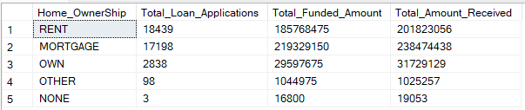

*When the Grade A in the filters for dashboards:*

SELECT

home_ownership AS Home_OwnerShip,

COUNT(id) AS Total_Loan_Applications,

SUM(loan_amount) AS Total_Funded_Amount,

SUM(total_payment) AS Total_Amount_Received

FROM

bank_loan_data

WHERE

grade = 'A' AND address_state = 'CA'

GROUP BY

home_ownership

ORDER BY

COUNT(id) DESC;

